1. Agenda:
   1. Creating Signup/Register API.
2. 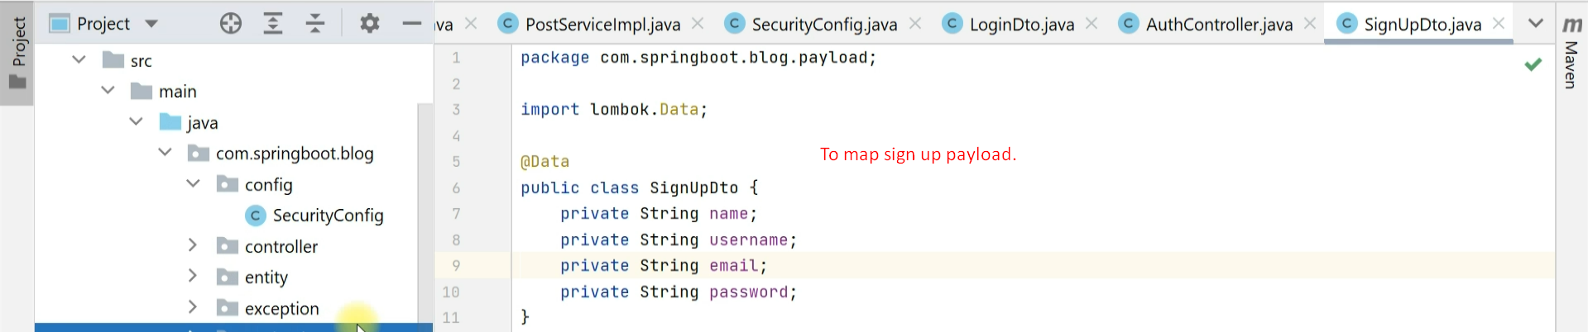
3. 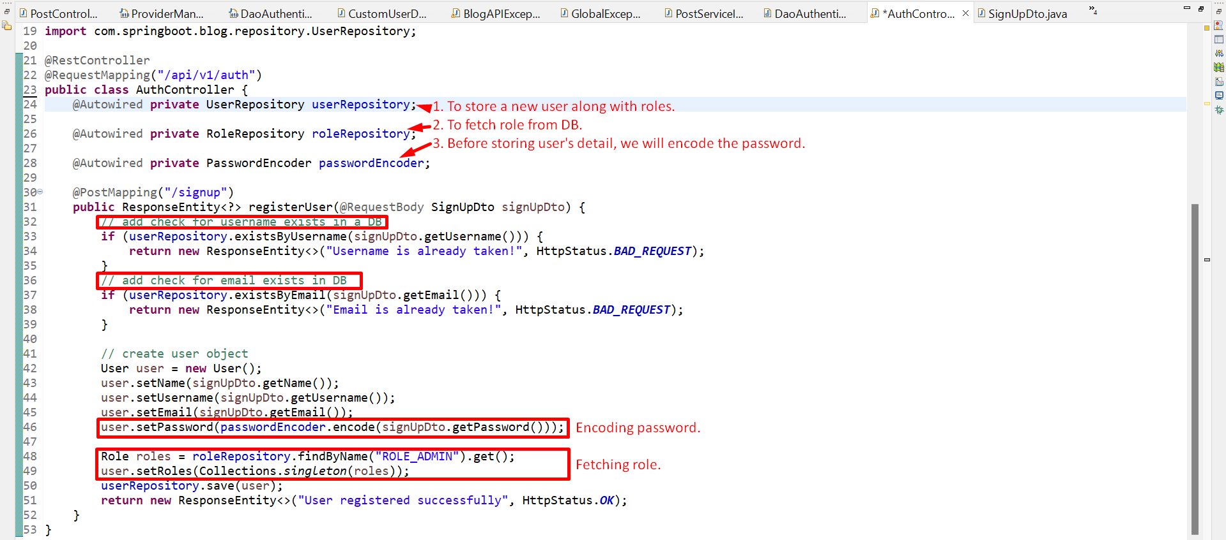
4. 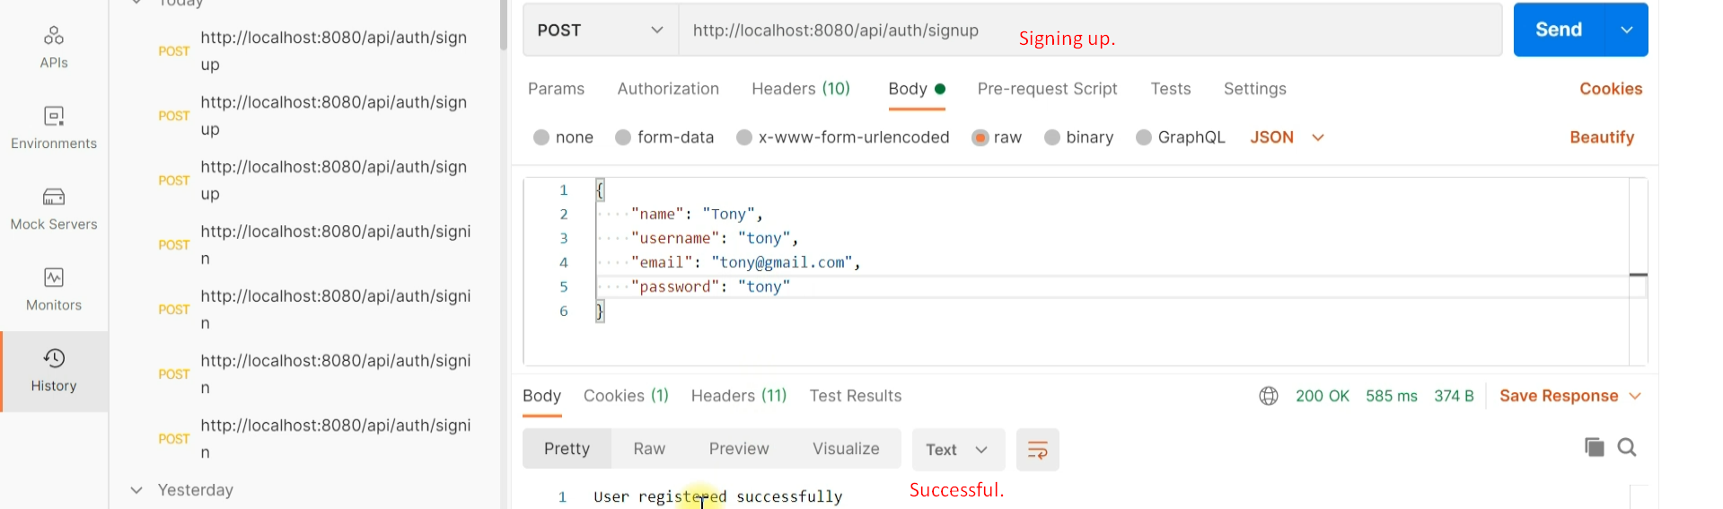
5. 